**The empirical analysis of CAPM in Shenzhen Real Estate Stock Market**

**Abstract**

This article used the A share of Shenzhen real estate stock market, on the one hand, it is to test to the validity of CAPM, on the other hand, using the empirical analysis is to find the underlying issues about the financial markets and policy makers can use the conclusion to make some relevant policies. The results of the test show that the market of Shenzhen real estate stock market does not hold the test of CAPM.

**Keywords**: CAPM; Shenzhen real estate stock market; systematic risk

# **1.Introduction**

Shenzhen is once voted as the most attractive city in China in 2017, is located between Guangzhou and Hong Kong. Shenzhen Special Economic district was established in August 1980. Due to the reform and opening up policy, its inclusiveness and openness has enabled tens of thousands of people to settle down in this vigorous city and brought about tremendous changes. The past 20 years of development in Shenzhen also witness the significant change in property market. The figure 1 showing In 1999, the average property price in Shenzhen was 5004 (CNY/square meters) and in 2019, the price has increased by 994.924% and reached about 54790(CNY/square meters).

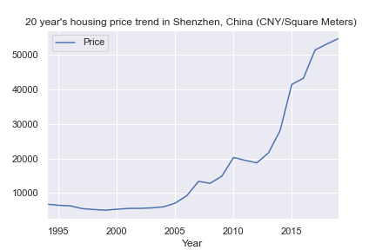

Fig 1: 20 years’ housing price trend in Shenzhen, China.

In this paper, we use the closing data including Shenzhen Stock Exchange, and real estate sector index from May 1st, 2011 to May 1st, 2019 to analyze the trend of real estate development.

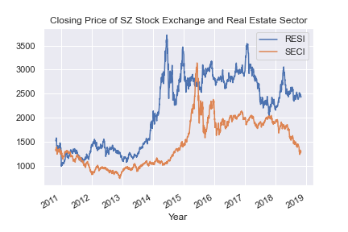

Fig2: Closing price of Shenzhen Stock Exchange and Real Estate Sector, the horizontal line shows the data from Nov 1st, 2010 to Nov 1st, 2019. The vertical line shows the closing price of trading in both Shenzhen Stock Exchange and Real Estate Sector (measured by CNY).

Source: the historical data is collected from baostock.

In 2010, China started the so called” real estate regulation policy. Specifically, Chinese state council issued policies requiring a minimum down payment of 40% on the loan of a second-house purchase. In addition, the property tax, policies were imposed in Shanghai and Chongqing started to issue the property tax (Note: on January 28, 2011, Shanghai and Chongqing announced to start the property tax on all homes except the first homes for local residents with and without “hukou”. The tax rate was at 0.6%.). However, the property price increased rapidly despite the tax.

From fig 2, there are three hikes from 2010 to 2019, this mainly attributes to the interests or public housing und mortgage rates started by the Central bank, that improved the confidence of home buyers. Property sales increased dramatically, especially in the first-tier cities, Shenzhen is one of the representatives. In 2017, due to regulation and control policies to the real estate market and increased mortgage rate, the price underwent a decline.

In general, for the household, whether to purchase housing will have great impact with one family, it seems to make investment on housing industry will bring a fundamental return. Is the same case in real estate stock market? The fluctuation of housing price is closely related with the expected return of residents’ investment and in the long run has significant impact on the national economic development. However, due to the liquidity in the stock market, it is inevitable for the property stock market to have fluctuation and bubbles which will makes the investment in stock market very risky to some extent. Therefore, it is very necessary to analyze the risk in real estate stock market as this will not only benefit the household’s income but also the national economic development. (Jun Li, 2009)

# **2. Capital Asset Pricing Model**

## 2.1 Overview of CAPM theoretical framework

CPAM model was built on the earlier work on [diversification](https://en.wikipedia.org/wiki/Diversification_(finance)) and [modern portfolio theory](https://en.wikipedia.org/wiki/Modern_portfolio_theory), which was later improved by Sharpe, Markowitz and Merton Miller. In 1960s. The CAPM developed in the 1960s was a true revolution in financial theory, due to their contribution, William F. Sharpe received the Nobel prize [in Economic Sciences](https://en.wikipedia.org/wiki/Nobel_Memorial_Prize_in_Economic_Sciences) in 1990 This Model basically is for estimating the capital assets using a linear equilibrium model of returns on investments that explains returns above risk-free rate using covariance with the overall market. (Džaja & Aljinović,2013). In market equilibrium the CAPM expresses the relationship between an asset’s expected return and so-called systematic risk beta in a liner function. (Sharpe, Litner, Mossin, 1966).. CAPM predicts that the expected return on an asset equals the risk-free rate plus a risk premium, it is linearly related to systematic risk measured by the assets’ beta. (Basu and Chawla, 2010). Due to the simplicity and rationality of CAPM, CAPM still remains very popular in many situations.

In the development of the asset pricing model, the assumptions of the models are ( Džaja Aljinović,2013)( Basu& Chawla, 2008)( Blac ,Jensen& Scholes, 1972)

1. Investors are risk averse and willing to maximize their expected rate of return over a period
2. Investors prefer a portfolio with higher returns
3. Free to lend and borrow with a risk-free interest
4. The property is indefinitely divisible
5. Trade without transaction or taxation costs.

## 2.2 Literature Review

Numerous empirical tests have been done, Fama and MacBeth (1972) did the test showing a positive tradeoff between market portfolio and risk, and average returns reflect the attempts of risk-averse investors to hold efficient portfolios, which are consistent with the model’s assumptions. After taking the firm size and the book-to market equity into consideration, some researcher like Banz(1981) did the tests there was a strong negative relation between average return and firm size, Fama & French(1992) showed in the results, the cross-sectional variation in average stock returns mainly were associated with this two factors. Pandey and Kok Chee (2000) used the panel data showing Beta was found to have consistently positive correlation with the stock returns but had weak explanatory power compared with the size.

But there are more failing empirical tests like Džaja & Aljinović (2013) who applied this model using monthly stock returns, the results show the CAPM is not adequate for assessing the capital assets on the Central and South- East European emerging securities markets, and the validity of beta is not a valid measure of risk in the experimental markets. Basu and Chawla did the test in India stock market concluding CAPM had weak explanatory power as a suitable descriptor of asset prices in India over the chosen sample.

The majority tests did by Chinese researchers shows CAPM’s failing explanatory power in stock market, some tests concluded significant correlation( Feng, 2010), some tests show nonlinear correlation(Zhou, 2013), while some tests agree with the CAPM consumptions, Zhu (2010) agreed positive correlation and there was no significant linear correlation with nonsystematic risk.

This article mainly use the A share in real estate industry to test whether Shenzhen as the new rapidly developing city, its capital market is mature enough to hold the CAPM tests showing the positive linear correlation, in another words whether the higher investment risk will bring higher return in stock market.

## 2.3 Methodology

In empirical analysis, this model is expressed:

$R_{p}=R_{f}+β_{p}\left(R_{m}-R_{f}\right)+ε_{p}$ (1)

where $R_{p}$ is the expected return of individual or portfolio stock in real estate industry, 𝑅𝑓 is a risk-free interest rate, 𝑅𝑚 represents the expected return of a market portfolio, 𝛽𝑝 measures the systematic risk of individual stock or market portfolio and 𝜀𝑝 is the stochastic error term. In this paper, CAPM is used to analyze the Shenzhen property stock market and test whether the effectiveness of this model is verified.

This paper is to use time series regression based on CAPM model to make estimation about the individual and portfolio β, which will be useful to understand the risk about Shenzhen real estate market; cross sectional regression-based method developed by Black, Jensen and Scholes (1972) is to verify the relationship between risk and expected return.

The detailed steps are: First, separate the whole time range from May 1st, 2010 to May 1st, 2019 into three periods; Second: Use the data in the first period to calculate the beta for individual stock; Third, rank the individual beta of each stock from lowest to highest, and make different portfolios; Fourth: use the data of second term to estimate the portfolio beta; fifth, make the cross sectional regression using the third period data coupled with these portfolio betas to determine the relationships between expected return and risk. The reason why the data is divided is that this was done to make the diversification and thus to reduce the error resulting from the presence of unsystematic risk. (Tao Zhao, 2001) (Wang and Geng, 2012) (Zhu, 2010) ( Basu and Chaw a, 2013)

# **3. Data**

In this paper, the research object is 58 real estate stocks in Shenzhen Stock Exchange from Nov 1st, 2010 to Nov 1st, 2019, in which three companies are extremely short of relevant data, that is why these three samples are deleted. The three companies are Dongfeng Sci-Tech Group (sz000160), Guangdong Jadiete Hldgs(sz 000168) and China Merchants Shekou Industrial Zone Holdings (sz001979) respectively.

The data is collected from BaoStock, this is a free, open source securities data platform providing a large number of accurate, complete securities historical, financial data of public companies. Data information is obtained through python.

Here, Shenzhen Stock Exchange is regarded as the market portfolio and the return on stock of SZCI as the return of market portfolio. The Chinese researchers normally will either do the split-adjusted share prices about the data in stock markets (Wang& Geng, 2012), or reverse split-adjusted share prices (Liao& Wang, 2003) (Zhao, 2013). In this paper, all the data are collected using the reverse split-adjusted share prices, this is to consider the influence of dividend, allotment and stock segmentation on the data (Zhao, 2013).

Regarding the return on every stock, there are two methods of calculation, one is logarithmic algorithm, using this way( Sakouvogui and Nganje, 2019), the data processed is approximately normal distribution, which is useful to improve the stability of time series; another is to subtract the closing price of the specific stock at the ending term and the initial closing price and then divide by the beginning closing price. (Zhao, 2013) (Wang & Geng 2012)

Here, in order to ensure the stability of time series, percentage change is used to calculate the daily return about stocks.

$R_{it}=\frac{P_{it}-P_{i(t-1)}}{P_{i(t-1)}}$ (2)

where, 𝑃𝑖𝑡 is the closing price of stock i at moment t, 𝑃𝑖(𝑡−1) is the closing price at moment t-1.

# **4. Statistical Analysis**

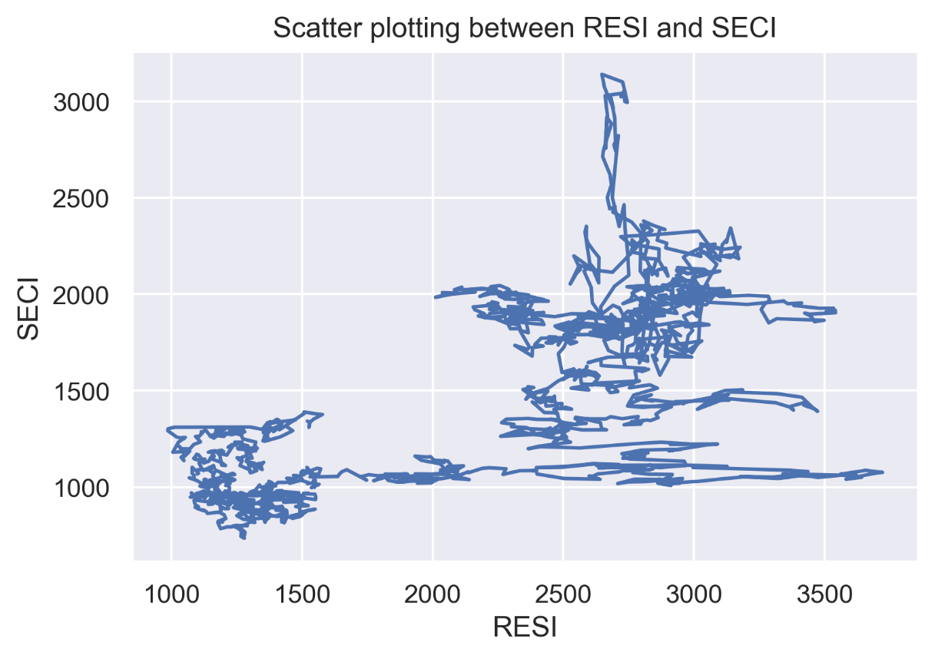

As shown in Fig 2, the majority of scatter plot are not distributed around the 45-degree line, it is [dispersed](javascript:;) [distribution](javascript:;), it can be concluded there is no clear linear correlation between Shenzhen Stock Exchange and Real Estate Sector.

# **5. Empirical analysis**

This paper uses time series regression and cross section regression to make empirical analysis. In order to reduce the errors of the empirical process, time ranges are divided into three periods: Nov 1st,2010 to Oct 31st, 2013; Nov 1st ,2013 to Oct 31st ,2016; Nov 1st, 2016 to Nov 1st, 2019.

## 5.1 Estimation for individual stock

Rewrite the equation (1) into (3), Use Single Index Model estimation:

$R_{it}$ − $R_{f}$ = $α_{i}$ + $β_{i}$ ($R_{mt}$ − $R_{f}$) + $ε_{it}$, (3)

where $R_{it}$ is the daily return of stock i at time t; $R_{mt}$ is the return of market portfolio; $R_{f}$ is the return of the risk-free asset, here $R_{f}$ equates 0.009027% (one-year deposit rate on bank of China) as Chinese researchers basically regard the deposit rate as risk free asset by default, (Liao and Shen, 2004).

Table 1: Summary results of time series about 48 property stocks of Shenzhen Stock Market

|  |  |  |  |  |  |
| --- | --- | --- | --- | --- | --- |
| **Code** | **Beta** | **R-Square** | **Code** | **Beta** | **R-Square** |
| sz.000667 | 0.7238 | 0.454 | sz.002016 | 0.9532 | 0.281 |
| sz.000608 | 0.7261 | 0.333 | sz.000514 | 0.9566 | 0.375 |
| sz.000002 | 0.7481 | 0.289 | sz.000671 | 0.9622 | 0.249 |
| sz.000668 | 0.7489 | 0.329 | sz.000961 | 0.9625 | 0.258 |
| sz.000402 | 0.7853 | 0.458 | sz.002146 | 0.9625 | 0.241 |
| sz.000691 | 0.7932 | 0.199 | sz.000797 | 0.9687 | 0.306 |
| sz.000560 | 0.7969 | 0.321 | sz.000897 | 0.9765 | 0.325 |
| sz.000573 | 0.8226 | 0.374 | sz.000718 | 1.0052 | 0.321 |
| sz.000007 | 0.8242 | 0.193 | sz.002244 | 1.0052 | 0.34 |
| sz.000732 | 0.8383 | 0.226 | sz.002285 | 1.0069 | 0.294 |
| sz.000965 | 0.8627 | 0.328 | sz.000926 | 1.0535 | 0.405 |
| sz.000042 | 0.8661 | 0.281 | sz.000631 | 1.0656 | 0.312 |
| sz.000615 | 0.8689 | 0.33 | sz.002208 | 1.0667 | 0.402 |
| sz.000838 | 0.8758 | 0.289 | sz.002147 | 1.0781 | 0.459 |
| sz.000656 | 0.8835 | 0.237 | sz.000736 | 1.0812 | 0.293 |
| sz.000517 | 0.8865 | 0.285 | sz.000043 | 1.086 | 0.291 |
| sz.000031 | 0.9046 | 0.428 | sz.000502 | 1.1004 | 0.347 |
| sz.000069 | 0.9073 | 0.365 | sz.002377 | 1.1208 | 0.362 |
| sz.000616 | 0.9105 | 0.361 | sz.000540 | 1.1216 | 0.36 |
| sz.000036 | 0.9128 | 0.307 | sz.000537 | 1.1435 | 0.376 |
| sz.000046 | 0.9194 | 0.305 | sz.000014 | 1.1653 | 0.29 |
| sz.000006 | 0.9301 | 0.311 | sz.000011 | 1.1924 | 0.332 |
| sz.002133 | 0.9355 | 0.445 | sz.000909 | 1.2205 | 0.467 |
| sz.000558 | 0.9503 | 0.265 | sz.002077 | 1.2413 | 0.43 |

From Table 1, it is clear to see the lowest beta value of individual stock is 0.72, the average beta value is 0.96, this means for the property stock, this is high risk investment industry.

$R^{2}$ represents the systematic risk accounts for the whole risk, for single share in the market, the average $R^{2}$ is 0.33, which represents the majority risk is the unsystematic risk.

## 5.2 Portfolio constructed

According to the estimated Beta of single stock in Table 1, its value is ranked from lowest to highest, and grouped into six market portfolios, each one portfolio contains 8 single stocks. The lowest 8 stocks are put into the first group, the highest 8 are in the sixth group. The following graph shows the results of grouping a sequence of Betas.

Table 2: portfolios about A share of real estate stocks in Shenzhen

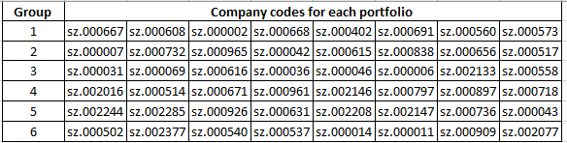

Rewrite equation one into (4)

$R_{pit}=R_{f}+β_{pit}\left(R_{mt}-R_{f}\right)+ε_{pit}$, (4)

where $R_{pt}$ is the return of six portfolios at time t; $R_{mt}$ is the average market return at time t. Because in real stock market, investors normally use the same amount to make investments and portfolios, in this paper, simple arithmetic average is adopted to calculate the average portfolio return. (Xu and Zhang, 2005）

$R_{pit}=\sum{R_{it}/N}$ (5)

𝑅𝑝𝑖𝑡 is the return on portfolio i at time t; 𝑅𝑖𝑡 is the single stock i at time t; N is the number of shares in a portfolio, in this paper, N=8.

According to the data in the second period, do time series regression on the different portfolios and the whole market return rate using OLS, obtain the portfolio betas for this six groups and the standard deviation of residuals $σ_{p}$, the results shows in Table (3)

Table 3: Summary of portfolio beta for six market portfolios

|  |  |  |  |
| --- | --- | --- | --- |
| Portfolio | $$β$$ | $$R^{2}$$ | $$σ_{p}$$ |
| 1 | 0.8357 | 0.698 | 0.011038 |
| 2 | 0.9749 | 0.719 | 0.011508 |
| 3 | 1.0875 | 0.741 | 0.012909 |
| 4 | 1.0979 | 0.718 | 0.013827 |
| 5 | 1.0634 | 0.748 | 0.012404 |
| 6 | 1.1163 | 0.791 | 0.011508 |

## 5.3 Cross Sectional Regression about risk and expected return

Use the third period data and the estimated portfolio beta using equation (4), cross sectional regression is estimated using equation (6)

$R_{pi}=γ_{0}+γ_{1}β_{pi}+ε_{i}$ (6)

In equation (6), $R_{pi}$ is the daily average return rate from Nov 1st, 2016 to Nov 1st, 2019, $γ_{0}$ and $γ_{1}$ are the coefficients which need to be estimated, $ε_{i}$ is residual error. The data needed is shown in table (3). To be consistent with the previous calculation with the daily return rate, logarithmic algorithm is still here used to calculate the daily return of stocks.

Table 4: Summary for the average return on portfolio and beta

|  |  |  |  |
| --- | --- | --- | --- |
| Portfolio | Average return rate | $$β_{p}$$ | $σ_{p}$ |
| 1 | -0.000452 | 0.8357 | 0.011038 |
| 2 | -0.00051275 | 0.9749 | 0.011508 |
| 3 | -0.000614 | 1.0875 | 0.012909 |
| 4 | -0.000236 | 1.0979 | 0.013827 |
| 5 | -0.0005875 | 1.0634 | 0.012404 |
| 6 | -0.0007145 | 1.1163 | 0.011508 |

### 5.3.1 The test between risk and return correlation

Regress on the six equations in table 3, the results shown in table (6), the model 2 is the regress using robust standard error.

Table 5: Summary for regression using equation (6)

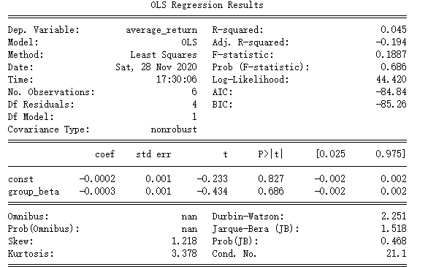

The regression show: $R^{2}$ =0.045, this explains lower fitness for this model, the p-value for constant and variable are both much larger than the normal significance level even at 10%, in another word variable is not significant at 10 % and the correlation between the expected return and market risk( measured by Beta) is not significant, CAPM has weak explaining power about this correlation. Meanwhile, $γ_{0}$ is negative and its coefficient value is -0.0003, the deviation from risk-free interest might be due to the opportunistic investment behavior. The negative coefficient on $γ_{1}$ is negative which is not consistent with the CAPM theory which says the positive correlation between expected return and risk, therefore, we can conclude there is no linear correlation between stock market portfolio and market systematic risk. This negates the validity for CAPM on A share of property stocks in Shenzhen.

Next, add the new variable $σ_{pi}$ and obtain another estimation regression:

$R_{pi}=γ_{0}+γ_{1}β_{pi}+γ_{2}σ_{pi}+ε_{i}$ (7)

Table 6: Regression summary for adding the residual variable

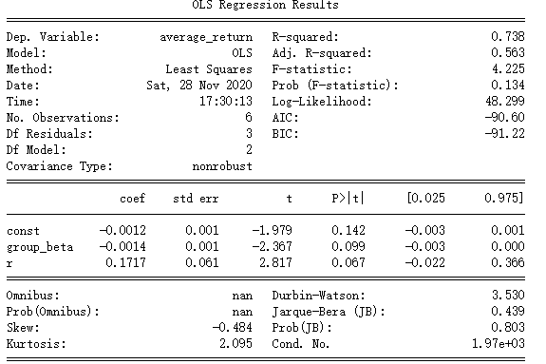

The regression results show in table 6. $R^{2}$ =0.728, this explains higher fitness for the model, the p-value for portfolio-beta is significant at 10% and residual is also significant at 10%. After adding the new variable of error term, the variable portfolio-beta is statistically significant, however, the coefficient about portfolio-beta is still negative. This result can be interpreted as adding the error into the equation, the average return rate is closely related with the systematic risk, but the linear correlation is still not verified.

Then, quadratic variable $β_{pi}^{2}$ and obtain another estimation regression including residual.

$R_{pi}=γ_{0}+γ_{1}β_{pi}+γ_{2}σ_{pi}+γ_{3}β_{pi}^{2}+ε_{i}$ (8)

For CAPM hypothesis, the hypothesis in the below should be satisfied.

$γ_{1}$ >0 as there should be a positive correlation

$γ_{3}=0$ as linear correlation requires.

$γ_{2}=0$ as residual risk could be diversified away after making portfolio and this should not affect the return.

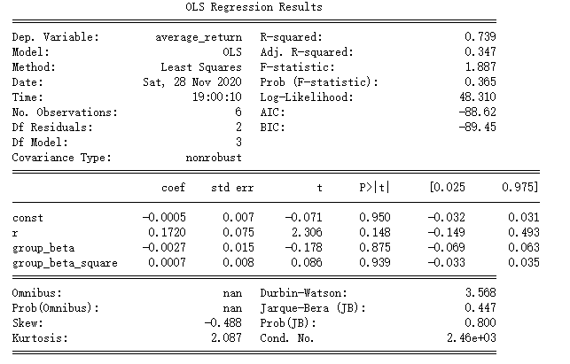

The regression results show $R^{2}$ =0.739, only the variable residual is statistically significant at 20%, but the coefficient is bigger than zero, which is also inconsistent with the CAPM theory saying effective diversification could reduce the unsystematic risk. The hypothesis listed is not satisfied, the equation and the variables are not statistically significant, the independent variables have weaker power to explain the dependent variables. The results again question the validity of CAPM and the risk-return theory in the context of Shenzhen real estate stock market.

Regress variables between group beta and quadratic variables group beta squared and average return.

Table 7 Regression between average return and quadratic variable $β_{pi}^{2}$

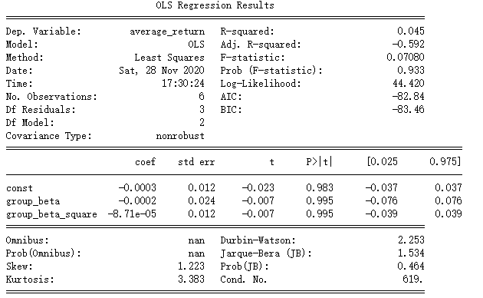

The regression results show in table 7. $R^{2}$ =0.045, this explains lower fitness for the model, the p-value for residual is not significant even at 20%. After adding the new variable of quadratic term, the model is not statistically significant and the null hypothesis cannot be rejected.

Regress variables between average return and residual only.

Table 8: Regression summary between residual and average return

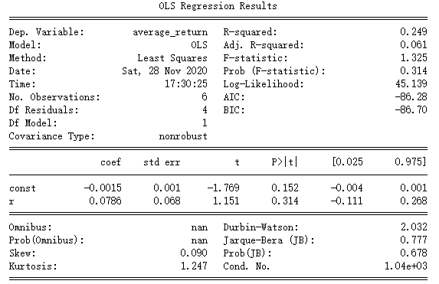

The regression results show in table 7. $R^{2}$ =0.249, this explains lower fitness for the model, the p-value for residual is not significant even at 20%. After adding the new variable of error term, the model is not statistically significant, however, the coefficient about portfolio-beta is still negative. And this means the residual has weak power of explaining the average return.

According to the regress results using equation (7)-(8), there is no strict linear correlation between expected return in real estate stock and market return, systematic and unsystematic risk. CAPM does not hold the test in the real estate stock market in Shenzhen.

# **6. Conclusion**

In this article, the time series and cross sectional regress was done to test the validity of CAPM about the property A share of Shenzhen stock market, the results show that (1) there is no strict positive correlation between the expected return and systematic risk which does not agree with the requirements of CAPM theory; (2) $γ_{0}$ is negative and its coefficient value is -0.00027, the deviation from risk-free interest can be possibly resulted from the opportunistic investment behavior;(3) the unsystematic risk is necessary to be paid close attention, which might be due to the imperfect stock market system, for example, Chinese securities market and information disclosure system are still immature and needs further to be improved. Therefore, CAPM is not so efficient in Shenzhen real estate stock market over the chosen sample period.

The CAPM is not completely valid in Shenzhen real estate stock market, but it still has reference value for the future stock market development, linear correlation between risk and return is the significant requirement for a mature capital market. Even though Shenzhen is undergoing a significant development as a whole, however, in the financial market, it is still not mature as the invertors make investment more out of opportunistic purpose. Property stock market is still very risky and close attention needs to be paid about the rapid fluctuation. More strict policies are necessary to be made to restrain the rapidly increasing of property price and the opportunistic investing behaviors.

# **Reference**

1. Josipa Džaja , Zdravka Aljinović. “TESTING CAPM MODEL ON THE EMERGING MARKETS OF THE CENTRAL AND SOUTHEASTERN EUROPE”. Croatian Operational Research Review (CRORR), Vol. 4, 2013
2. Fischer Black, Michael C,Jensen Myron Scholes.”The Capital Asset Pricing Model: Some Empirical Tests.” Studies in the Theory of Capital Markets, Michael C. Jensen, ed., Praeger Publishers Inc., 1972
3. Eugene F. Fama; Kenneth R. French.” The Cross-Section of Expected Stock Returns” The Journal of Finance, Vol. 47, No. 2. (Jun., 1992), pp. 427-465.
4. Banz, Rolf W., 1981, The relationship between return and market value of common stocks, Journal of Financial Economics 9, 3-18.
5. Pandey, Hong Kok Chee, “ The expected stock returns of Malaysian Firms: A panel data analysis”
6. Debarati Basu, Deepak Chawla, “An Empirical Test of CAPM—The Case of Indian Stock Market” . GLOBAL BUSINESS REVIEW, 11:2 (2010): 209–220
7. Sakouvogui Kekoura, Nganje William. 2019. “Robust CAPM Estimation through Cross-Validation.” The journal of Finance data Science, Spring 2019
8. Tao Zhao. 2001 “Application of capital asset pricing model in Shanghai 180 stock market.” Statistics and decision-making 2001, issue 24 · total issue 396
9. Jun Li. 2009. “Application of CAPM in risk analysis of real estate investment.” Business China, 2009. Issue 2
10. Eugene F. Fama and James D. MacBeth, “Risk, Return, and Equilibrium: Empirical Tests”, The Journal of Political Economy, Vol. 81, No. 3 (May - Jun. 1973), pp. 607-636
11. Josipa Džaja, Zdravka Aljinović. “TESTING CAPM MODEL ON THE EMERGING MARKETS OF THE CENTRAL AND SOUTHEASTERN EUROPE”, Croatian Operational Research Review CRORR. Vol. 4, 2013
12. Eugene F. Fama and Kenneth R. French.” The Capital Asset Pricing Model:Theory and Evidence”, Journal of Economic Perspectives—Volume 18, Number 3—Summer 2004—Pages 25–46
13. Rolf W. BANZ, “THE RELATIONSHIP BETWEEN RETURN AND MARKET VALUE OF COMMON STOCKS*”, Journal of Financial Economics 9 (1981) 3318. North-Holl and Publishing Company
14. I. M. Pandey, Hong Kok Chee. “THE EXPECTED STOCK RETURNS OF MALAYSIAN FIRMS: A PANEL DATA ANALYSIS”, 12(2000) ,SSRN Electronic Journal
15. Zhu Shun quan. 2010. “Empirical Studies on the CAPM in China Capital Market.” Statistics & Information Forum. Vol.25 No 8. Aug 2010
16. Zhou.” Capital asset pricing model based on liquidity risk”, Chinese Journal of Management Science, Vol 21, No.5.Oct ,2013
17. Pei Feng. “An Empirical Research on Whether CAPM suits for Chinese Stock Market", Journal of Xi’an University of Finance and Economics, Vol 23 No 4 Jul, 2010